[Trello Board](https://trello.com/b/PSg0U9VH/labs-22-swaap)

# Breakdown Entry: Week 3

## Prompt 1

Describe the breakdown process of your first release.

(Note to TL: The Trello board doesn’t show it, but I’m the one that added the motivation/finish line on all the user stories. They were just title only before I did that.)

### Include a screenshot of your current Trello board.

* + 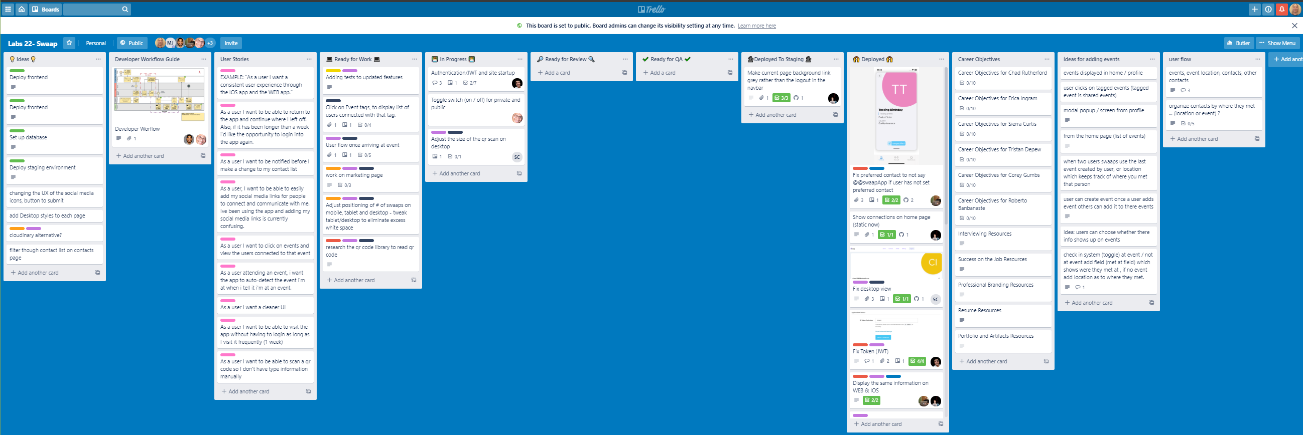

### What are the user stories you broke your first release into? Please list them out.

* + 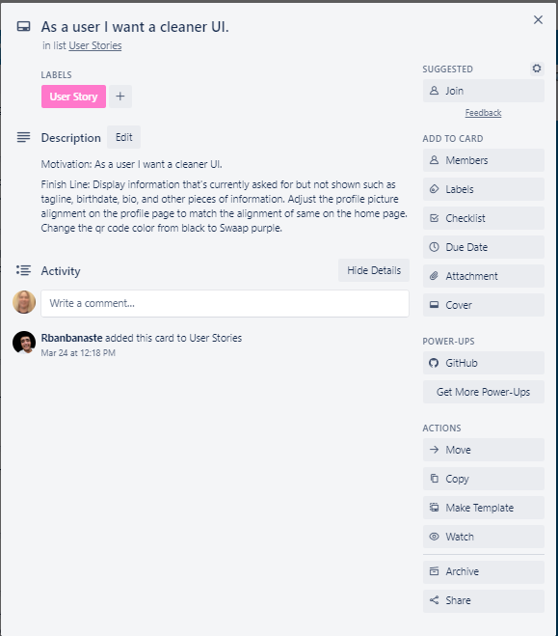
  + 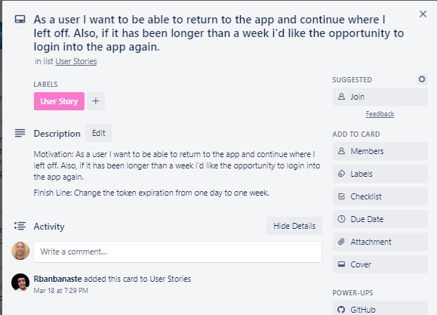
  + 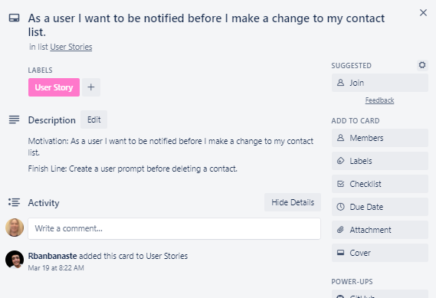
  + 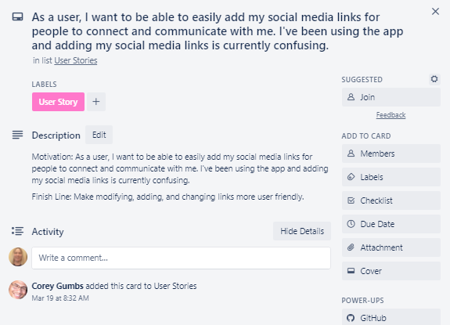
  + 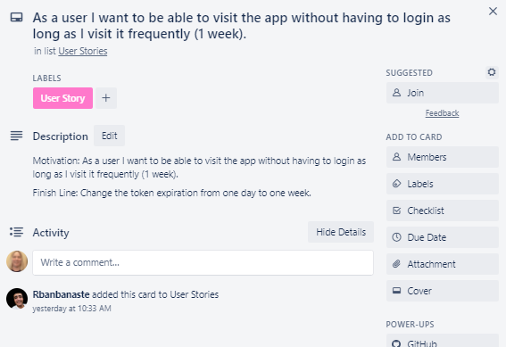

## Prompt 2

Find a Trello card that is assigned to you.

### Include a screenshot of the detailed Trello card

* + 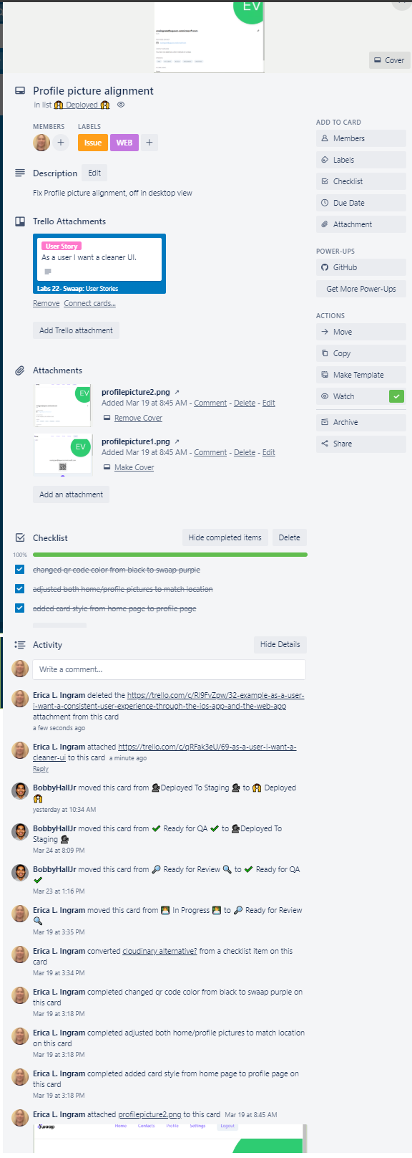

### How does this task tie to the overall product vision?

* + Completing this task provides a more consistent user experience, which ties in to two of our objectives, making sharing profile info very fast and easy as well as having a positive experience staying in contact with people from a conference.

### What steps go into completing this task? How long do you think it will take you to deliver this task?

* + Go get the container divs which make the ‘card’ and make an identical container holding the profile information. Also adjust the Tailwind CSS classes to make the profile page picture match the home page picture. The full actual task took me about 30 minutes.

## User Story Quiz

For this quiz we'd like you to spend time writing out User Stories the same way that we did in class together during Sprint 2. Use the link below:

### Create a new trello board and make sure you make it public (DONE)

### Include a Motivation and finish line for each user story (DONE)

## Do not forget to submit your User Stories link to your Trello board in your Journal Entry response for this week. (DONE)

* + [Trello Board](https://trello.com/b/PSg0U9VH/labs-22-swaap)